**Lesson 3 Demo 4**

**Managing and Administering a Kubernetes Cluster**



Steps to be followed:

1. Verifying the certificates of the cluster
2. Viewing the cluster information
3. Creating a namespace
4. Accessing clusters using Kubernetes API

**Step 1: Verifying the certificates of the cluster**

1. Check certificate expiration as the regular user

***sudo kubeadm certs check-expiration***

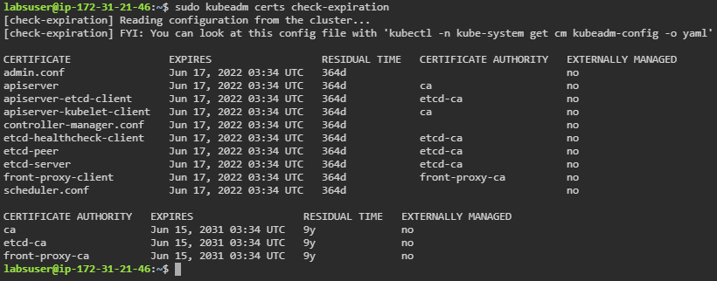

**Step 2: Viewing the cluster information**

1. Enter the following command in the master node:

***kubectl cluster-info***

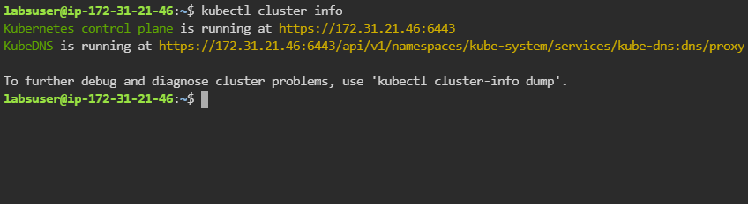

**Step 3: Creating a namespace**

1. Use the following command to create a namespace:

***kubectl create namespace firstnamespace***



1. Verify the newly created namespace in the master node

***kubectl get namespaces -A***

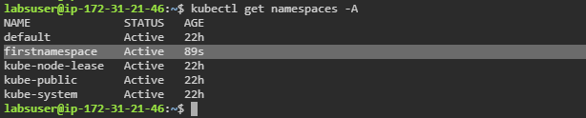

**Step 4: Accessing clusters using kubernetes API**

1. View the cluster configuration using the following command:

***kubectl config view***

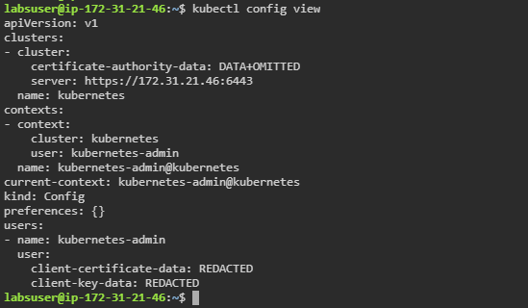

1. Locate the API server by running the following command:

***kubectl proxy --port=8080***



1. Click on **master** tab on the lab and then click on the **desktop** option

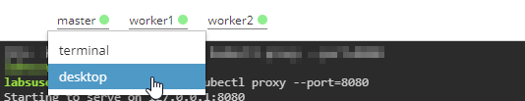

1. Navigate to the **desktop** tab and open **Firefox** browser to access the **API server** by typing the ip-address and port mentioned in step 4.2 output

